**Online** **Retail Segmentation and Analysis Report**

**Name: Liaqat Ali Khan**

**Email Adress:** [**liaqat.pu@gmail.com**](mailto:liaqat.pu@gmail.com)

**Github Profile Link:**

**Project Overview:**

Customer segmentation is a widely adopted strategy that enables organizations to effectively categorize clients based on a variety of factors. This report presents the analysis performed on a dataset containing transactional information, aiming to uncover valuable insights that can guide business decisions and strategies.

**1. Distribution of Order Values Across Customers:**

To understand the distribution of order values across all customers in the dataset, we calculated the total order value for each customer. This allowed us to observe how customers' spending varies.

SELECT

CustomerID,

SUM(Quantity * UnitPrice) AS TotalOrderValue

FROM online_retail

GROUP BY CustomerID ORDER BY TotalOrderValue;

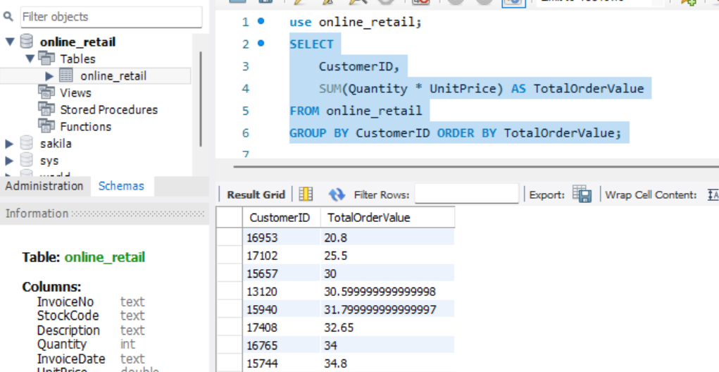

**2. Unique Products Purchased by Each Customer:**

Analyzing the dataset, we determined how many unique products each customer has purchased. This information provides insights into customer engagement and preferences. The analysis revealed diversity in customer behavior, with some purchasing a broad range of products and others focusing on specific items.

SELECT

CustomerID,

COUNT(DISTINCT StockCode) AS UniqueProductsPurchased

FROM online_retail

GROUP BY CustomerID ORDER BY UniqueProductsPurchased DESC;

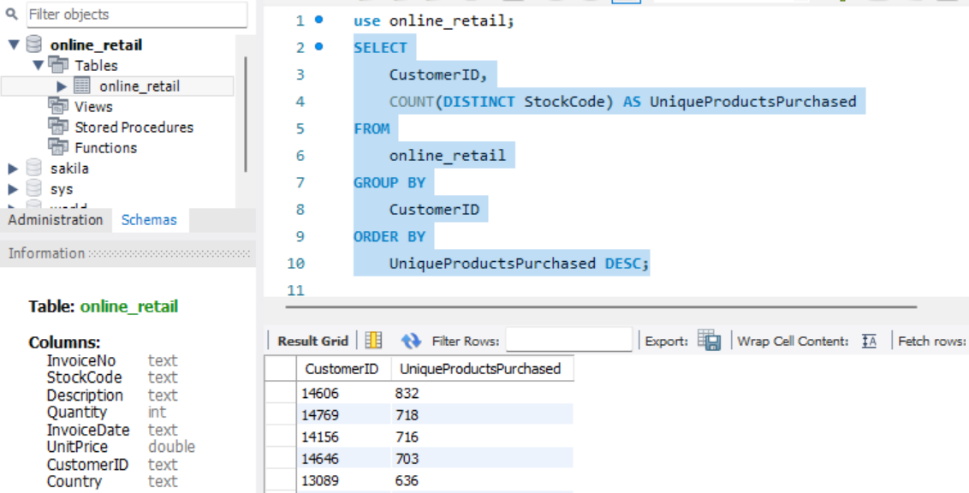

**3. Single Purchase Customers:**

Identifying customers who have made only a single purchase from the company is crucial for understanding customer retention. We identified a group of customers who made just one purchase. This segment requires special attention and tailored communication to encourage repeat purchases and increase engagement.

SELECT

CustomerID, COUNT(DISTINCT InvoiceNo) AS TotalPurchases

FROM online_retail GROUP BY CustomerID HAVING TotalPurchases = 1;

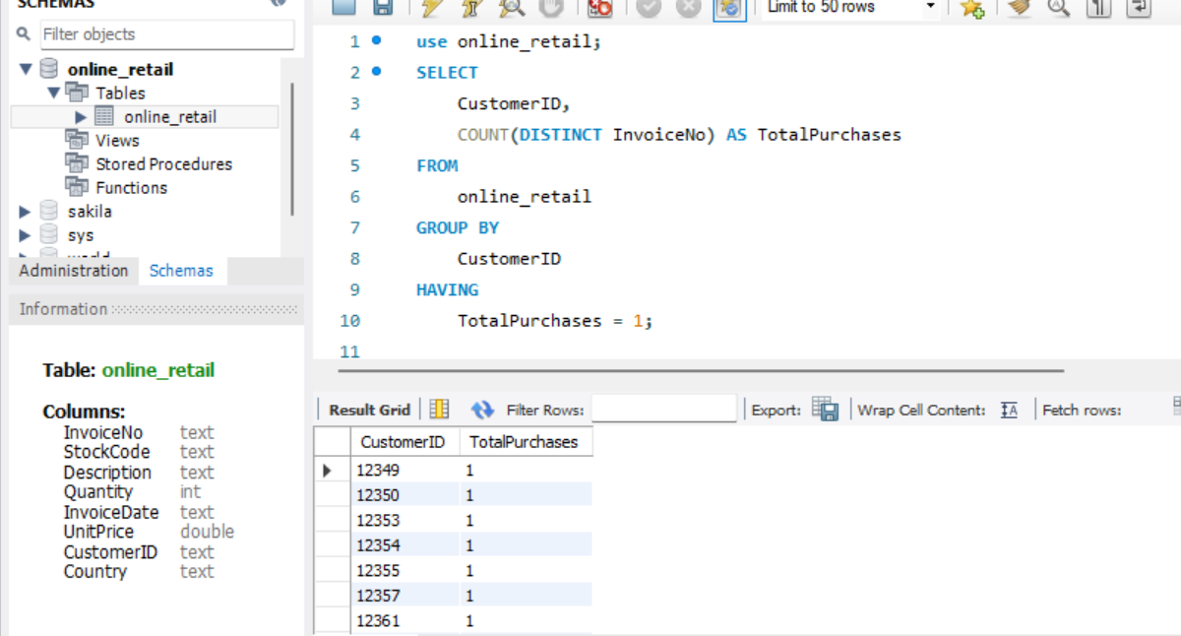

**4. Product Affinity Analysis**:

We conducted a product affinity analysis to uncover which products are often purchased together by customers. Utilizing correlation between product purchases, we identified common product pairs. This knowledge can inform cross-selling strategies and help enhance product recommendations.

SELECT

p1.StockCode AS Product1,

p2.StockCode AS Product2,

COUNT(DISTINCT p1.InvoiceNo) AS CommonInvoices

FROM

online_retail p1

JOIN

online_retail p2 ON p1.InvoiceNo = p2.InvoiceNo AND p1.StockCode < p2.StockCode

WHERE

p1.InvoiceDate BETWEEN '12/1/2010 8:26' AND '12/1/2010 9:02'

GROUP BY

p1.StockCode, p2.StockCode

ORDER BY

CommonInvoices DESC LIMIT 0, 50;

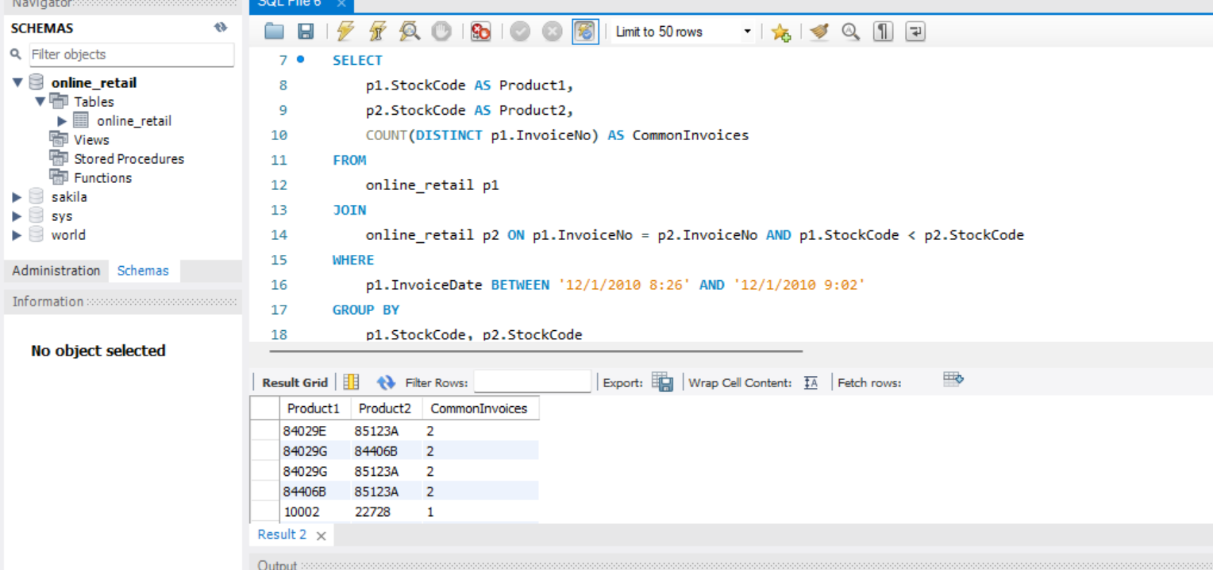

**5. Time-based Analysis:**

Exploring trends in customer behavior over time, we performed a time-based analysis to identify monthly or quarterly sales patterns. This provides insights into seasonality, trends, and potential opportunities for targeted marketing campaigns.

SELECT

InvoiceDate AS YearMonth,

SUM(Quantity) AS TotalQuantity,

SUM(UnitPrice * Quantity) AS TotalRevenue

FROM online_retail

GROUP BY

YearMonth

ORDER BY YearMonth;

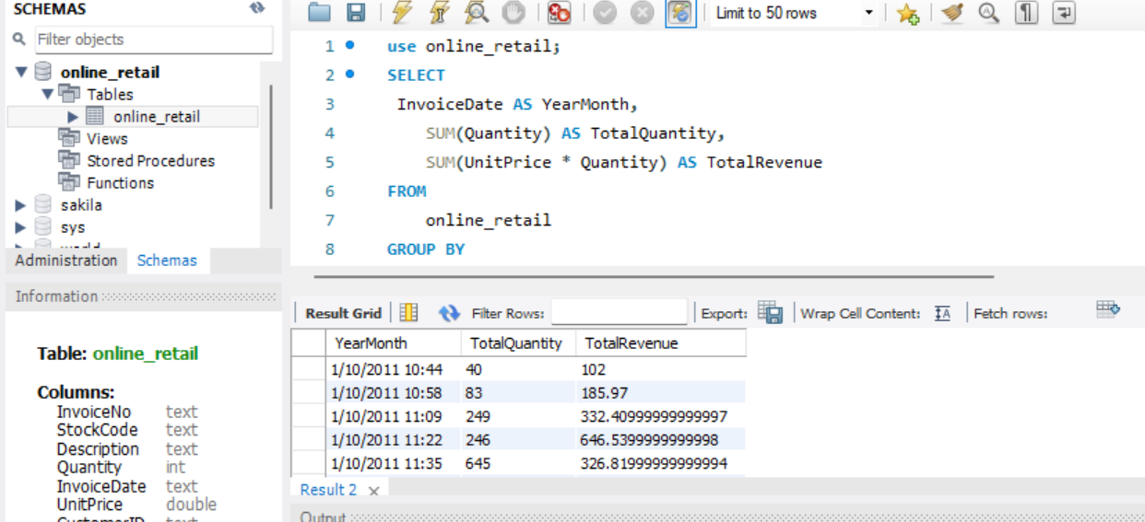

**Additional Insights and Opportunities:**

**Customer Segmentation by Purchase Frequency:** Grouping customers based on their purchase frequency helps in identifying loyal customers and those needing more attention.

**Average Order Value by Country:** Analyzing order values by country reveals geographic differences in customer spending patterns.

**Customer Churn Analysis:** Identifying inactive customers over a specific period helps assess customer churn and implement retention strategies.

**Conclusion:**

Incorporating customer segmentation and analysis into business strategies can enhance customer satisfaction, personalized engagement, and overall business performance. By leveraging the insights gained from this dataset, organizations can make informed decisions that positively impact their growth and success.